Form 1: ICCA Registry INFORMATION SHEET FOR Free, Prior and Informed Consent

Project Title
A Global Registry for Understanding Indigenous and Community Conserved Areas (ICCA)

Purpose of the Project
This project will document Indigenous and Community Conserved Area (ICCA) importance for biodiversity conservation and livelihoods through a global Registry and a highly visual and informative website, which will constitute a systematic knowledge base about ICCAs. Expected outcomes are: increasing awareness about ICCA values, favouring the engagement of local and traditional communities in policy arenas, and promoting locally appropriate official recognition of ICCAs.

How will your information be used?
Information and data will be collected and used for:

- Global and national-level analyses that document the status of ICCAs and their contribution to conservation through various means. The analyses will be based on the data and information you provide. The analytical results will be available to the public and will not contain any information or data that will make you or the data you provide identifiable unless you agree to this in advance.
- Increasing global awareness of ICCAs through a visual presence on the internet. Information, such as the name and size of the ICCA and associated communities, would be viewable through an interactive website using on-line maps. This will include photos, participatory videos, interviews and stories from ICCAs as well as some useful statistics from the national and global analysis. The uploading and accessibility of any of this will need to be specifically agreed by you in advance.

Ownership of information provided
The ownership and control of any intellectual property rights and information provided remains with the indigenous peoples or local community who contributes it. UNEP-WCMC will not use this information for commercial purposes, nor will it be transferred to third parties for commercial purposes. Any information made accessible on the internet will be approved by the community in the FPIC form,

In general, information for the Registry can be shared in these three ways, determined by those providing the data and specified in the FPIC form:
- Information is open to all or can be open to all
- Information is open to Registry managers, and to others with prior permission of information providers (permission given on a case by case basis from representatives of the relevant IPs or LC)
- Information is not open to anyone other than Registry managers, under any circumstance

Information you can provide
This registry will contain the following:

- Descriptive or general information about your ICCA (collected through a questionnaire, interview, documents, participatory discussions or field observations)
- Analysis and opinions regarding various aspects of your ICCA (collected as above)
- Photos and video regarding the ICCA, the community, local management, conservation impacts. Clips of interviews and quotations from community members, and/or others associated with or knowledgable about the ICCA, are also strong contributions.
- Maps and/or spatial data that can provide information about the location of the ICCA (fig. 1) or the exact boundaries of the ICCA (fig. 2).

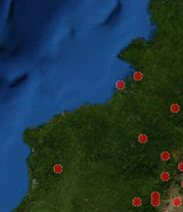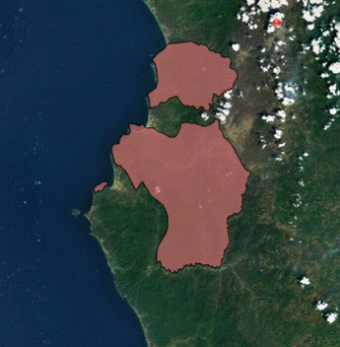

Fig. 1 Point/location data on a map Fig. 2 Boundary data on a map

Any of the information and data you provide may be used for the national or global analysis, but you will specifically agree about which data (i.e. attribute, point or boundary) you want to be made available to the public, and to what extent (i.e. on the website, only to other ICCAs members, or not available at all) – see the FPIC form. New information can be added and existing information updated or removed at the request of the data provider.

Risks & Benefits
The relevant Indigenous People and Local Communities are the primary stakeholders and often best suited to judge whether there is a risk involved by participating in this process. If you anticipate any such risks (for instance, that may arise from popularising or publicising your site and initiative), please let us know. The extent to which your information is shared is in your control. The potential benefits derived from your participation in this project include increasing awareness and disseminating information about ICCAs in general and your ICCA in particular. Ultimately, this project can help demonstrate the values of ICCAs and the influence of this governance type on conservation and human well-being, thereby increasing the value of these areas for national and global processes and possibly providing access to increased and more relevant forms of support.

Consent
The consent of use of the data you are providing on behalf of your community is expressed through the Free Prior and Informed Consent form. UNEP-WCMC will work with the ICCA Consortium to ensure the validity of those who are providing information.

Project Contacts
Colleen Corrigan  Senior Programme Officer  Protected Areas Programme  UNEP-World Conservation Monitoring Centre Cambridge, UK  Email: colleen.corrigan@unep-wcmc.org  Phone: +44 (0) 1223 277 314 ext 267 | Arianna Granziera/ Siobhan Kenney  Assistant Programme Officers  Protected Areas Programme  UNEP-World Conservation Monitoring Centre Cambridge, UK  Email: iccaregistry@unep-wcmc.org  Phone: +44 (0) 1223 814681

